**MINI PROJECT-1**

**BOOK CATALOG SYSTEM**

**G.).** create table Users(User_Id int primary key,Username varchar(20) not null,Email varchar(20) unique not null,Phone_No int unique not null);

desc Users;

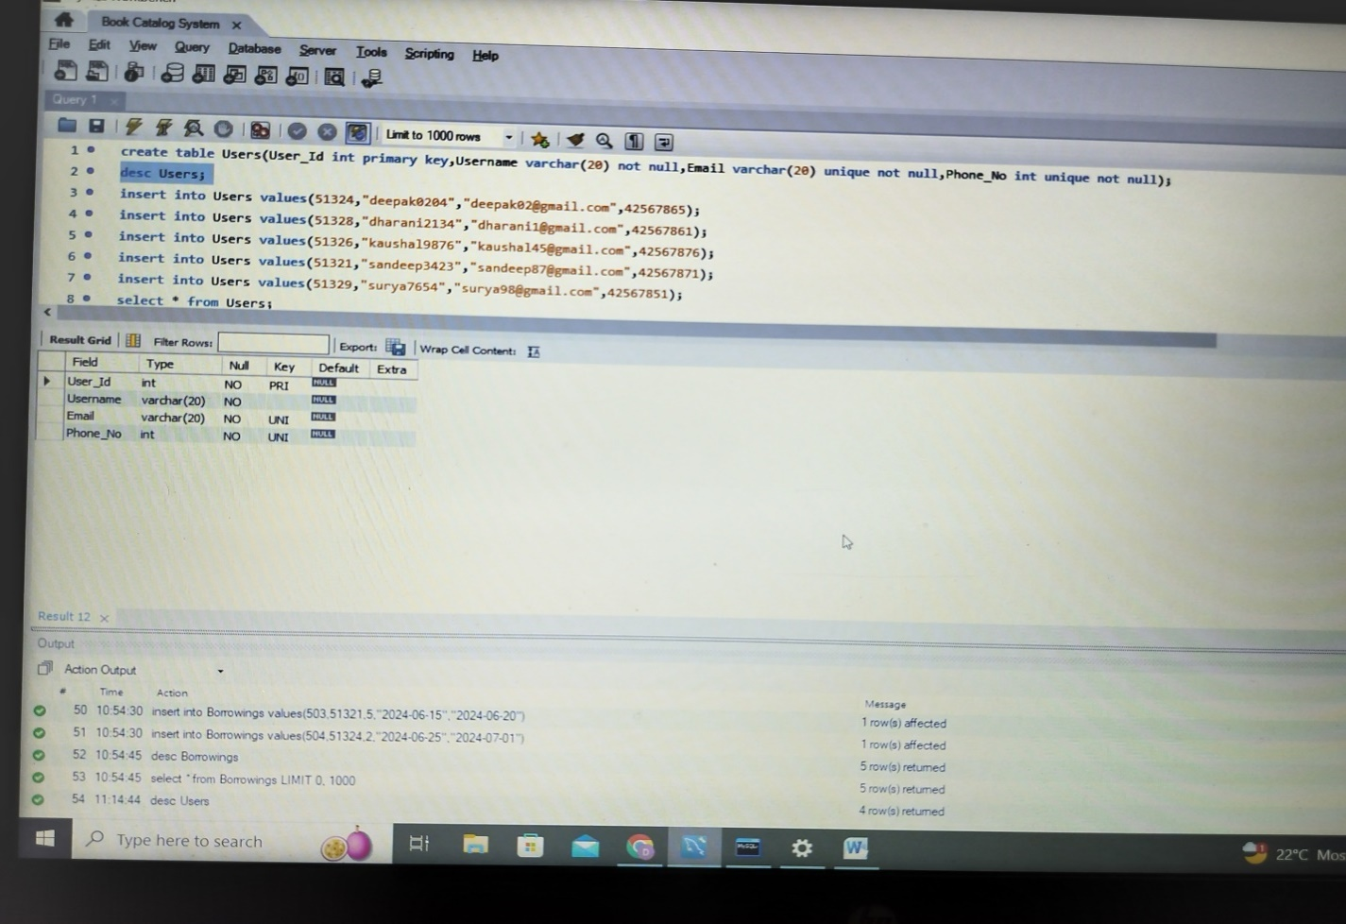

insert into Users values(51324,"deepak0204","deepak02@gmail.com",42567865);

insert into Users values(51328,"dharani2134","dharani1@gmail.com",42567861);

insert into Users values(51326,"kaushal9876","kaushal45@gmail.com",42567876);

insert into Users values(51321,"sandeep3423","sandeep87@gmail.com",42567871);

insert into Users values(51329,"surya7654","surya98@gmail.com",42567851);

select * from Users;

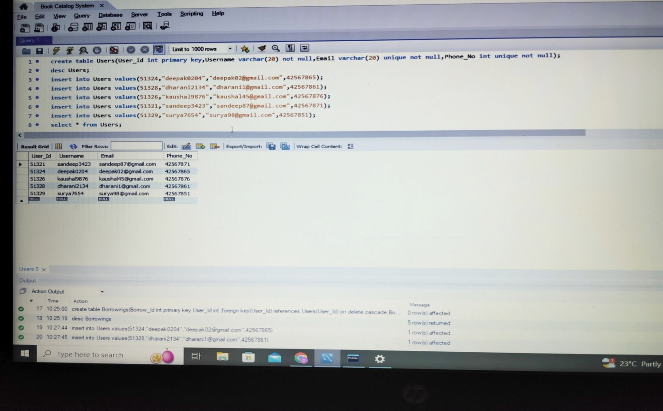

**C.).** create table Categories(Category_Id int primary key,Category_Name varchar(20) unique not null);

desc Categories;

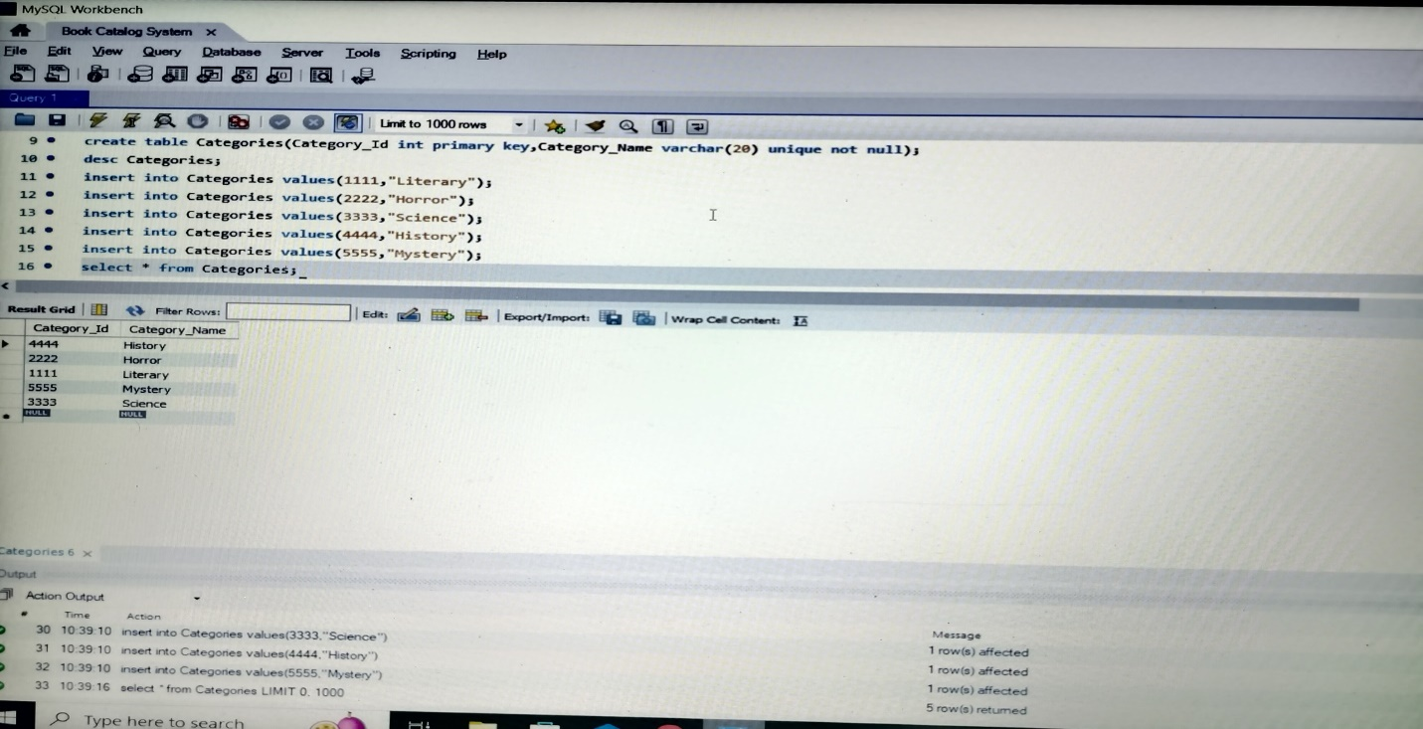

insert into Categories values(1111,"Literary");

insert into Categories values(2222,"Horror");

insert into Categories values(3333,"Science");

insert into Categories values(4444,"History");

insert into Categories values(5555,"Mystery");

select * from Categories;

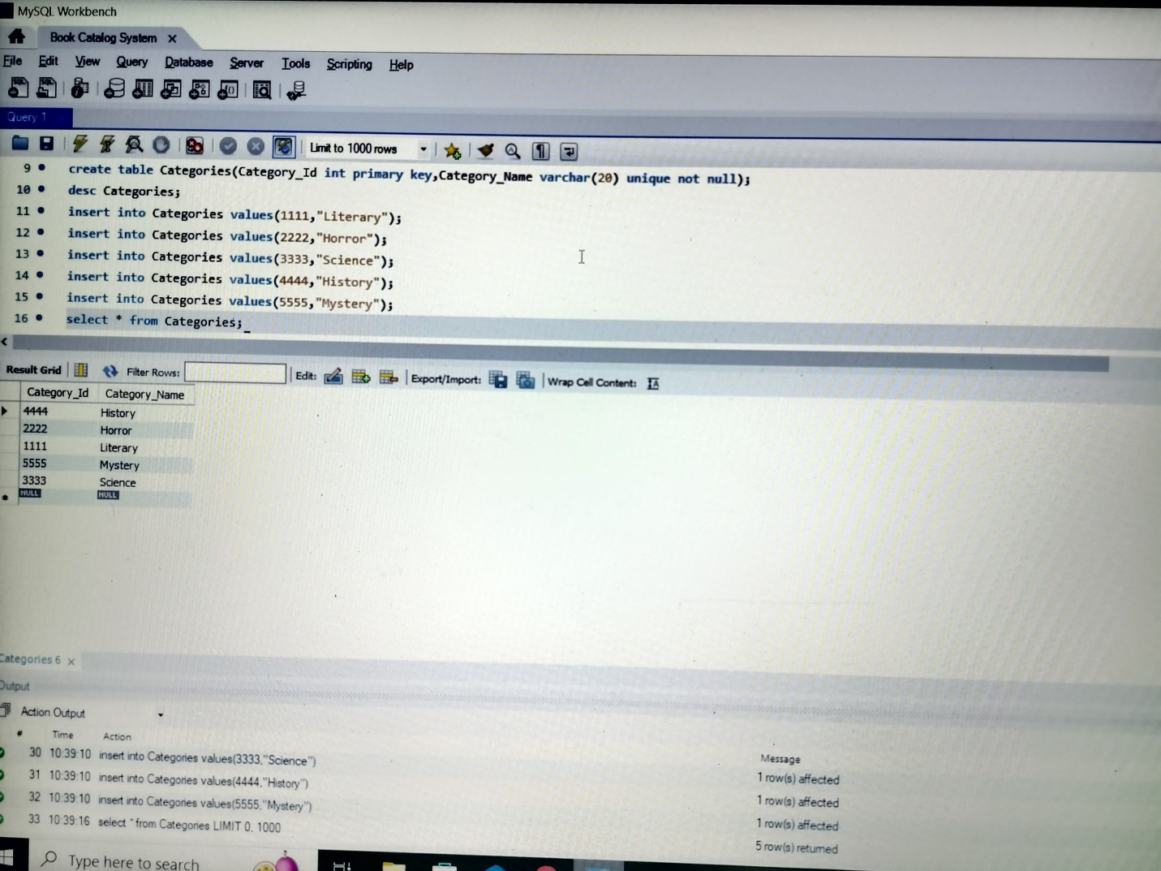

**E.).** create table Publishers(Publisher_Id int primary key,Publisher_Name varchar(20) not null);

desc Publishers;

insert into Publishers values(111,"Penguin Random House");

insert into Publishers values(112,"Hachette India");

insert into Publishers values(113,"Macmillan");

insert into Publishers values(114,"Gita Press");

insert into Publishers values(115,"HarperCollins");

select * from Publishers;

**A.).** create table Books(Book_Id int primary key,

Title varchar(20) not null,ISBN int unique not null,

Publication_Year year not null,Publisher_Id int,

Category_Id int,Author_Name

varchar(20) check(Author_Name!=null));

alter table Books add foreign key(Publisher_Id) references Publishers(Publisher_Id) on delete cascade;

alter table Books add foreign key(Category_Id) references Categories(Category_Id) on delete cascade;

desc Books;

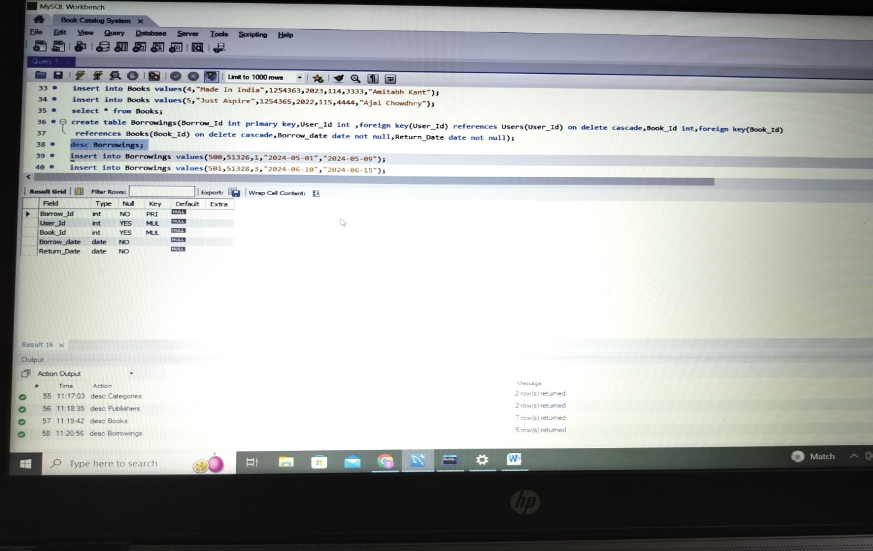

insert into Books values(1,"Harry Potter",1254367,2002,112,2222,"JK Rowling");

insert into Books values(2,"Gulivers Travels",1254368,1992,113,1111,"Jonathan Swift");

insert into Books values(3,"Reflections",1254361,2024,111,5555,"Narayanan Vaghul");

insert into Books values(4,"Made In India",1254363,2023,114,3333,"Amitabh Kant");

insert into Books values(5,"Just Aspire",1254365,2022,115,4444,"Ajai Chowdhry");

select * from Books;

**I.)** create table Borrowings(Borrow_Id int primary key,User_Id int ,foreign key(User_Id) references Users(User_Id) on delete cascade,Book_Id int,foreign key(Book_Id)

references Books(Book_Id) on delete cascade,Borrow_date date not null,Return_Date date not null);

desc Borrowings;

insert into Borrowings values(500,51326,1,"2024-05-01","2024-05-09");

insert into Borrowings values(501,51328,3,"2024-06-10","2024-06-15");

insert into Borrowings values(502,51329,4,"2024-06-30","2024-07-03");

insert into Borrowings values(503,51321,5,"2024-06-15","2024-06-20");

insert into Borrowings values(504,51324,2,"2024-06-25","2024-07-01");

select * from Borrowings;

